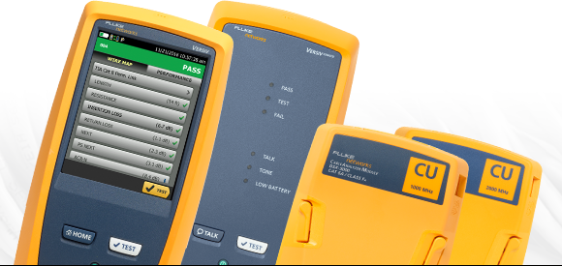

Datasheet: DSX CableAnalyzer™Series
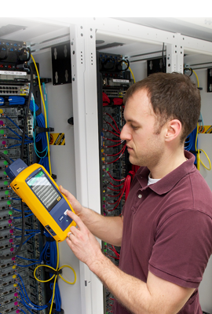
The DSX CableAnalyzer™ Series is the copper certification solution of the Versiv™ cabling certification product family. The DSX Series includes the DSX-8000, which can certify cabling up to Cat 8 / 2 GHz, and the DSX-5000 which can certify up to Cat 6A / Class F_{A} / 1GHz. The Versiv line also includes fiber OLTS certification, OTDR, and fiber inspection modules. Versiv reduces overall certification costs by up to 2/3, adding up to 10% to the bottom line of every job. While the fastest test time (8 seconds for Cat 6A) plays a part, the system is designed from the ground up to reduce errors and streamline certification. Full integration with the LinkWare Live cloud service lets the Project Manager remotely set up the testers, monitor job progress and even locate tester from any smart device.
With the DSX CableAnalyer and Versiv, you’ll save money every time you use it.

The DSX CableAnalyzer Series copper test solution enables testing and certification of twisted pair cabling for up to 40 Gigabit Ethernet deployments and will handle any cabling system whether it is a Cat 5e, 6, 6A, 8 or Class F_{A} and I/II. Certifying a cable is one part of a process that starts with system design and ends with system acceptance. The faster that process goes, the more profitable you’ll be. Unfortunately, there are a lot of things that slow the process down – setting up the tester incorrectly, testing to the wrong limits, waiting for skilled technicians to analyze and troubleshoot failures, misinterpretation of results, and producing test reports that customers cannot understand.
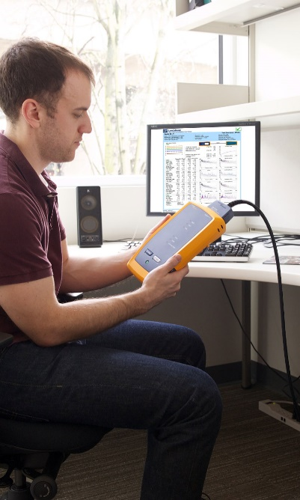
As part of the Versiv cabling certification product family, the DSX CableAnalyzer Series provides accurate, error-free certification. In the installation business there are multiple teams, varying media types and multiple testing requirements. The difference between being profitable or not is just a few percentage points. The DSX certifies copper cabling, complies with all standards including Level VI/2G accuracy, making jobs easier to manage, and getting to system acceptance faster. It’s not just for the expert technicians and Project Managers. Individuals of various skill levels can improve the set-up, operation, test reporting, and simultaneously manage diverse projects.
Unique features:
- Versiv enables users to accomplish more than ever with a cable tester, by accelerating every step of the testing process
- LinkWare Live cloud service lets the Project Manager remotely set up the testers, monitor job progress and even locate tester from any smart device
- ProjX™ management system eases tasks from initial set-up of a job to system acceptance. It eliminates redundant steps, and ensures that all tests are completed correctly the first time, and every time
- Taptive™ user interface puts advanced data analysis and easy set-up and operation at the fingertips of technicians of all skill levels
- LinkWare PC management software provides unmatched analysis of test results and professional test reports
- The DSX reduces the time required to fix cabling faults with dedicated diagnostics, a simple test that locates the problem
Performance:
- Eight second Cat 6A test time contributes to the fastest way to gain certification
- Graphically displays the source of failures including crosstalk and distance to shield faults for faster troubleshooting
- Manage up to 12,000 Cat 6A test results with full graphics
- Capacitive touchscreen allows quick tester setup with easily selectable cable types, standards and testing parameters
- Over 1 billion links reported on LinkWare PC management software
Standards:
- Compliant with ANSI/TIA-1152-A Level 2G and proposed standard IEC 61935-1 Ed. 5 Level VI field tester accuracy requirements to 2000 MHz
- Supports the complete suite of Resistance Unbalance standards needed for Power over Ethernet (PoE) – IEEE 802.3bt, ANSI/TIA/EIA-568, ISO/IEC 11801 series documents
- TCL and ELTCTL measurements compliant to IEC 61935-1-1 (Draft)
- Screen continuity along path of cabling

Versiv Platform is Ready for Today's and Tomorrow's Jobs
Electrically centered plug design is compliant with TIA Level 2G and IEC Level VI accuracy requirements to 2000 MHz with a future-ready design to support all hardware upgrades
The DSX CableAnalyzer Series enables cable testing and certification for network deployments up to 40 Gigabit Ethernet – whether it is an existing Cat 5e, 6, 6A, 8 or Class I/II cabling system, the DSX tests to all industry standards. The electrically centered test plug results in the Level 2G/VI accuracy required to support field testing to Cat 8 / Class I/II, 2000 MHz. The DSX exceeds the IEC Level VI and TIA Level 2G specifications assuring you of higher confidence in results over the full frequency range. Higher performance cabling systems like Cat 8 require more precise measurement to ensure they are providing the noise immunity required by 25G and 40G applications. Additionally, complex Alien Crosstalk link-to-link certification is simplified by integrating the measurement capability into each copper module up to 40GBASE-T testing.
The DSX is the first field tester to support balance measurements including Transverse Conversion Loss (TCL) and Equal Level Transverse Conversion Transfer Loss (ELTCTL). TCL and ELTCTL are important measurements found in the cabling standards. They define a minimum performance for balance, a key parameter to help determine noise immunity. Industrial network owners/operators are especially interested in this property due to the higher level of electromagnetic interference (EMI) within the industrial environment.
Fluke Networks' DSX CableAnalyzer Series has obtained Intertek (ETL) verification in accordance with the ANSI/TIA-1152-A specification for Level 2G test equipment. (Report on file.)
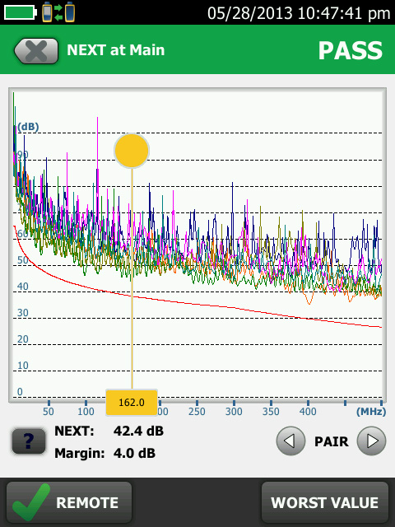
TLC Graph View
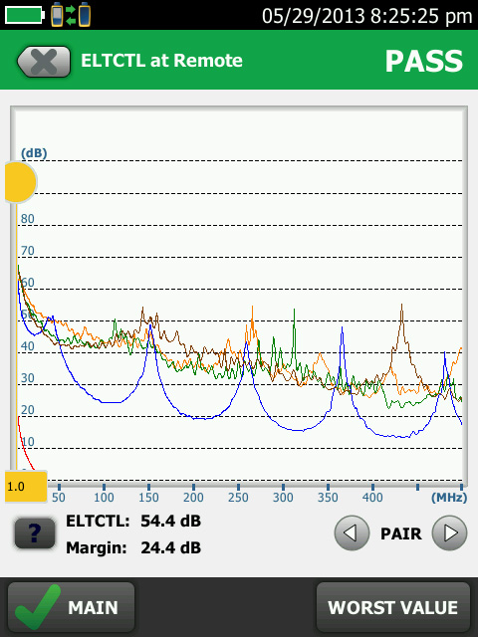
ELTCTL Graph View
ProjX Management System Manages Complex Jobs with Ease
Manage up to 12,000 Cat 6A test results with full graphics
Managing the testing of multiple jobs with multiple teams, testers, and requirements is time consuming and a source of errors. Increasingly larger jobs make project organization more important than ever. The ProjX management system on the DSX CableAnalyzer Series provides individual project files for all job specific details to be saved under a simple name, eliminating the need to re-enter job specific details after starting a project. This minimizes set-up errors or lost files when switching from one job to another or utilizing multiple testers on a single job. In addition, it provides test results by cable ID, merges any changes without duplicates and defaults to the last copper or fiber module installed. ProjX management system provides real time status to completion on each job with a 0-100% scale and gives the operator the option to isolate any test requiring a second look and helps to assure nothing is overlooked. The "Fix Later" selection creates a punch list or automatic to do list for correcting any workmanship issues. ProjX enables project managers and crew leaders to be truly efficient.
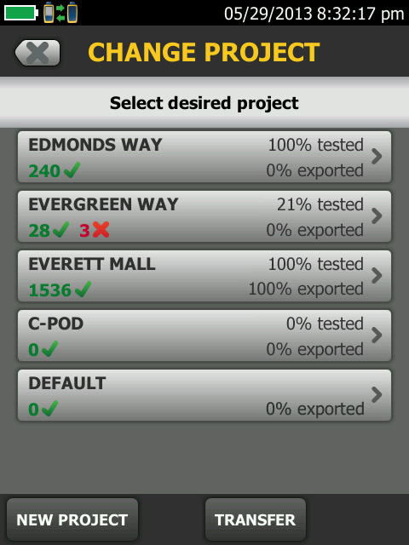
Project Menu screen shows percent complete per job
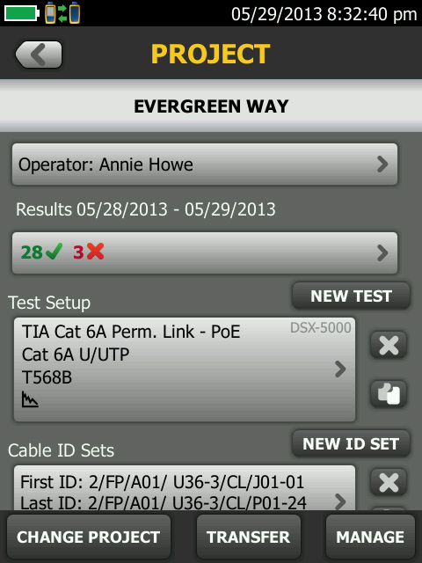
Project specific screen shows up to the minute project details
Taptive User Interface Simplifies Set Up, Eliminates Errors and Speeds Troubleshooting
Capacitive touchscreen allows quick tester setup and supports all standards
Taptive user interface is easy enough for even the newest technician to perform tests across multiple media types and testing requirements. The capacitive Taptive user interface makes all jobs easily accessible from the menu screen. Touch the job you’re working on and the large display confirms the test that needs to be performed, animated instructions simplify setting the configuration making correct testing assured.
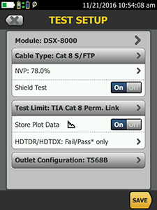
Simple Set up
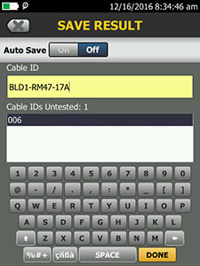
Quickly enter Cable Ids with the capacitive touchscreen
Performs with Unsurpassed Speed
Eight second Cat 6A test time and the fastest way to submit your certification results
No tester offers so much speed for so many tests. Complete copper certification to Cat 6A in 8 seconds or certify two fibers at two wavelengths in just 3 seconds. Endorsements by cabling vendors worldwide assure that Versiv is the fastest way to project completion and system acceptance. Quickly get a Pass or Fail result and easily review individual test parameters by value or drill into specific area on a graph.
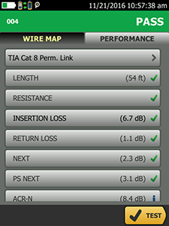
Passing test result
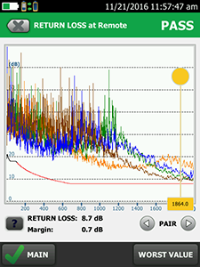
Return loss graph
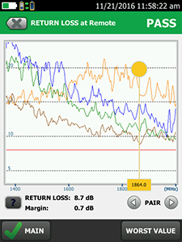
Pinch and zoom for more detail
Troubleshoot Like an Expert
Graphically displays the source of failures including crosstalk and distance to shield faults for faster troubleshooting
The DSX reduces the time required to fix cabling faults with dedicated diagnostics, a simple 1 button test runs all tests and saves all data. The graphical results screen allows you to look down the cable to see exactly where any cross talk, return loss or shield faults are located on any given link. Previous testers had frequency limits of their diagnostic capabilities of up to 250 MHz only, but the DSX CableAnalyzer Series removes this limitation. This common view is easily interpreted by novice and expert users alike to isolate and act on any failed results quickly and is stored with the test result for remote analysis.
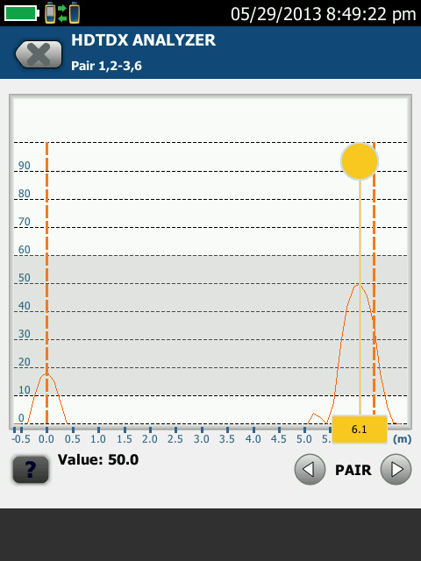
High Definition Time Domain Cross talk (HTDTX) shows the far end connection is clearly the issue
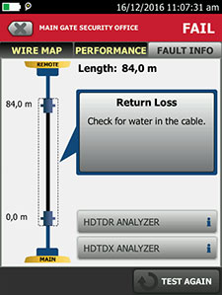
Features simple diagnostics based on decades of Fluke Networks troubleshooting experience
Shield continuity historically is a direct current (DC) measurement with no distance to fault available. Other testers run a simple resistance test to verify that the shield has continuity. These tests have been shown to be inaccurate, sometime confusing a ground path as shield continuity and not correctly identifying a break in the shield. Other testers may tell you there is a break in a shield, but not pinpoint the exact location giving no indication of where to start rework. The DSX CableAnalyzer Series is the first field tester to report distance to any shield integrity issues, reporting the true status of the screen continuity. This is especially important in datacenters and Cat 8 installations where screen continuity is critical to maintaining alien crosstalk performance of screened cabling.
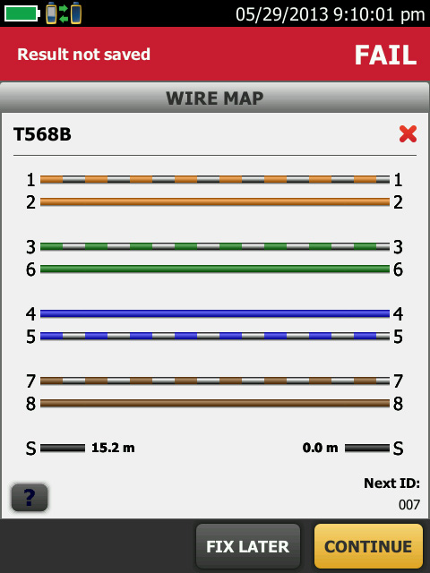
Wiremap – shows distance to fault, break and short
DSX CableAnalyzer Series Family
The DSX CableAnalyzer Series family is based on two modules: the DSX-5000 and DSX-8000. The DSX-5000 certifies twisted pair Cat 5e, 6, 6A and Class F_{A} cabling with limits up to 1000 MHz. The DSX-8000 certifies twisted pair Cat 5e, 6, 6A, Cat 8 and Class I/II cabling with limits up to 2000 MHz.
 | Copper Certification
 | DSX-8000 CableAnalyzer™ | DSX-5000 CableAnalyzer™
Cat 6A / Class E_{A} test time | 8 seconds | 10 seconds
Cat 8 / Class I/II test time | 16 seconds
HDTDX/HDTDR diagnostic test times | ≈ 3 seconds | ≈ 3 seconds
Internal memory | ≈ 5,000 Cat 8 with plots; ≈ 12,000 Cat 6A with plots | ≈ 12,000 Cat 6A with plots
>Level V Accuracy (1 GHz) | ✓ | ✓
Level VI/2G Accuracy (2 GHz) | ✓
Resistance Unbalance measurement | ✓ | ✓
Shield integrity check and distance to fault | ✓ | ✓
TCL measurement | ✓ | ✓
ELTCTL measurement | ✓ | ✓
CDNEXT measurement | ✓ | ✓
CMRL measurement | ✓ | ✓
Built-in Alien XTalk capability | ✓ | ✓
Channel Adapter | 2 GHz Range | 1 GHz Range
Permanent Link Adapter | 2 GHz Range | 1 GHz Range
Optional accessories
Patch cord adapter | Cat 5e, 6 and 6A patch cord | Cat 5e, 6 and 6A patch cord
Coax Adapter | ✓ | ✓
M12 Adapter | ✓ | ✓
TERA Adapter | Available Summer 2017 | ✓
GG45 Adapter | Available Summer 2017 | ✓
LinkWare Live
LinkWare Live is a cloud-based service that lets you manage certification jobs anytime, anywhere, with anyone on any device. With LinkWare Live, you can
- Keep track of every test on every job. Get an overview of every project from any smart device. Drill down to each individual test. Instantly receive notification of incorrect test setting or cable IDs.
- Get it right the first time. Define cable IDs and test settings from your PC or tablet. Then send them to the testers or Brother printers at the jobsite for mistake-free testing and labeling.
- Keep your testers up to date. Standards can change without notice, and an out-of-date test report can mean hours of re-testing. LinkWare Live automatically ensures your testers are running the latest.
- Stop wasting time and gas driving testers back to the office. Upload your test results straight from the job site to LinkWare Live over Wi-Fi. Then download them automatically to the right job for fast report generation with LinkWare PC.
- Avoid Project Delays. Track the last used location and monitor the status of all testers to ensure they are always calibrated and running the latest firmware.
- Supports all Versiv models: DSX CableAnalyzer Series, CertiFiber Pro, OptiFiber Pro, and the FI-7000.
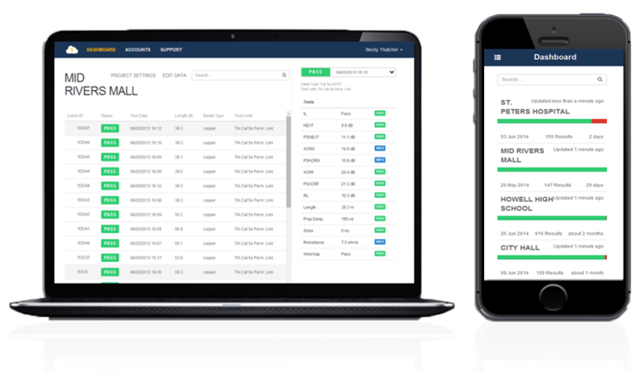
LinkWare PC Management Software
Leveraging the popular and multi-featured LinkWare PC management software application, DSX CableAnalyzer Series users can easily access the ProjX management system data, generate reports, and upgrade the software in their testers. Project Managers have full capabilities to manage workflow and consolidate test results. Users can provide the finishing touch by adding their company logo to the report and offer it unaltered to their customers for system acceptance purposes. Keep your business tools simple, no matter which Fluke Networks copper or fiber tester you are using, LinkWare PC is the software package that reports it all.
Now with LinkWare Stats, the new automated statistical report option, you can move above and beyond the page-per-link report and see your entire cabling infrastructure. It analyzes and transforms LinkWare PC test results data into charts and diagrams that reveal your cabling plant performance; this report summarizes your entire cabling infrastructure in a compact, graphical format that makes it easy to verify margins and to spot anomalies.
LinkWare PC Report
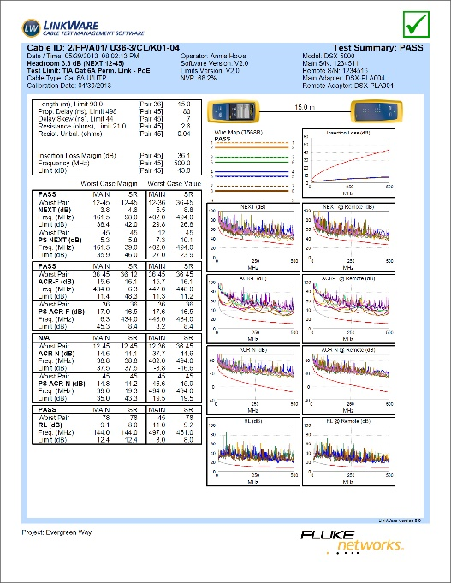
LinkWare Stats summarizes all
project data
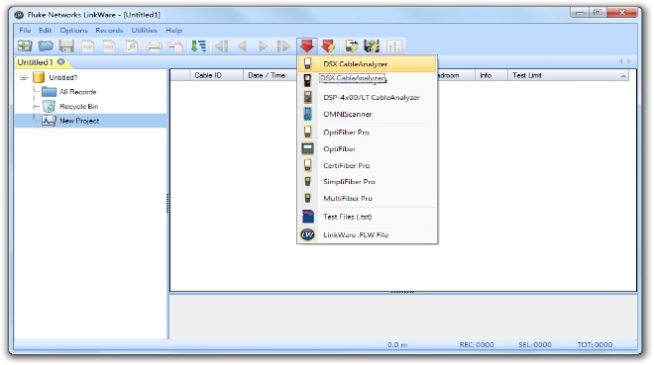
New versions of LinkWare PC are always backwards compatible with previous versions, so you can stay current and always integrate tests from different testers into test report.
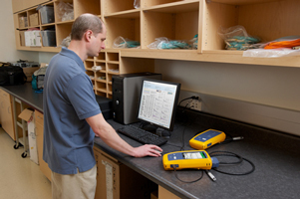
DSX CableAnalyzer Series Specifications
Cable Types
Shielded and unshielded  pair LAN cabling | TIA Cat 3, 4, 5, 5e, 6, 6A, 8: 100 Ω ISO/IEC Class C, D, E, E_{A}, F, F_{A} and I/II: 100 Ω and 120 Ω

Standard Link Interface Adapters
Permanent link adapters | Plug type: shielded RJ45
 | Optional Plug type: Tera (for DSX-5000 only, DSX-8000 version available summer 2017)
Channel Adapters | Jack type: shielded RJ45
 | Optional Jack type: Tera, GG45 (for DSX-5000 only, DSX-8000 version available summer 2017)

Test Standards
TIA | Cat 3, 4, 5, 5e, 6, 6A, 8 per TIA 568 Series
ISO/IEC | Class C, D, E, E_{A}, F, F_{A}, I/II certification per ISO/IEC 11801 Series
Maximum frequency | DSX-8000: 2000 MHz; DSX-5000 1000 MHz

General Specifications
Autotest Time | DSX-8000: Full 2-way Autotest of Cat 5e or 6/Class D or E: 7 seconds Full 2-way Autotest of Cat 6A/Class EA: 8 seconds Full 2-way Autotest of Cat 8: 16 seconds
 | DSX-5000: Full 2-way Autotest of Cat 5e or 6/Class D or E: 9 seconds Full 2-way Autotest of Cat 6A/Class EA: 10 seconds
Support test parameters (The selected test standard determines the test parameters and the frequency range of the tests) | Wire Map, Length, Propagation Delay, Delay Skew, DC Loop Resistance, Insertion Loss (Attenuation), Return Loss (RL), NEXT, Attenuation-to-crosstalk Ratio (ACR-N), ACR-F (ELFEXT), Power Sum ACR-F (ELFEXT), Power Sum NEXT, Power Sum ACR-N, Power Sum Alien Near End Xtalk (PS ANEXT), Power Sum Alien Attenuation Xtalk Ratio Far End (PS AACR-F)
Input protection | Protected against continuous telco voltages and 100 mA over-current. Occasional ISDN over-voltages will not cause damage
Display | 5.7 in LCD display with a projected capacitance touchscreen
Case | High impact plastic with show absorbing overmold
Dimensions | Main Versiv unit with DSX module and battery installed: 2.625 in x 5.25 in x 11.0 in (6.67 cm x 13.33 cm x 27.94 cm)
Weight | Main Versiv unit with DSX module and battery installed: 3 lbs, 5oz (1.28 kg)
Main unit and remote | Lithium ion battery pack, 7.2 V
Typical battery life | 8 hours
Charge time* | Tester off: 4 hours to charge from 10 % capacity to 90 % capacity
Languages supported | English, French, German, Italian, Japanese, Portuguese, Spanish, Chinese, Korean, Russian, Trad Chinese, Czech, Polish, Swedish, Hungarian
Calibration | Service center calibration period is 1 year
Environmental Specifications
Operating Temperature | 32° F to 113° F (0° C to 45° C)
Storage Temperature | -22° F to +140° F (-30° C to +60° C)
Operating relative humidity (% RH without condensation) | 0% to 90%, 32° F to 95° F (0° C to 35° C)
 | 0% to 70%, 95° F to 113° F (35° C to 45 °C)
Vibration | Random, 2 g, 5 Hz-500 Hz
Shock | 1 m drop test with and without module and adapter
Safety | CSA 22.2 No. 61010, IEC 61010-1 3rd Edition
Operating altitude | 13,123 ft (4,000 m)  10,500 ft (3,200 m) with ac adapter
EMC | EN 61326-1

Ordering Information
DSX-8000 Wireless models
(Available in the following countries: www.flukenetworks.com/VersivWiFiAdapter)
Model | Description
DSX-8000-W | DSX-8000 CableAnalyzer with Wifi adapter
DSX-8000-W/GLD | DSX-8000 CableAnalyzer with Wifi adapter and 1 year Gold Support
DSX-8000MI-W | DSX-8000 with Multimode OLTS and Fiber Inspection with Wifi adapter
DSX-8000MI-W/GLD | DSX-8000 with Multimode OLTS and Fiber Inspection with Wifi adapter and 1 year Gold Support
DSX-8000OI-W | DSX-8000 with Quad OTDR and Fiber Inspection with Wifi adapter
DSX-8000OI-W/GLD | DSX-8000 with Quad OTDR and Fiber Inspection with Wifi adapter and 1 year Gold Support
DSX-8000QI-W | DSX-8000 with Quad OLTS and Fiber Inspection with Wifi adapter
DSX-8000QI-W/GLD | DSX-8000 with Quad OLTS and Fiber Inspection with Wifi adapter and 1 year Gold Support
DSX-8000QOI-W | DSX-8000 with Quad OLTS, Quad OTDR and Fiber Inspection with Wifi adapter
DSX-8000QOI-W/GLD | DSX-8000 with Quad OLTS, Quad OTDR and Fiber Inspection with Wifi adapter and 1 year Gold Support
DSX-8000-PRO-W | Versiv Professional Kit with DSX-8000 CableAnalyzer, Quad OLTS, Quad OTDR, Fiber Inspection with Wifi adapter and a full complement of product accessories.
DSX-8000-PRO-W/GLD | Versiv Professional Kit with DSX-8000 CableAnalyzer, Quad OLTS, Quad OTDR, Fiber Inspection with Wifi adapter and a full complement of product accessories and 1 year Gold Support.
DSX-8000 Non-wireless models
Model | Description
DSX-8000 | DSX-8000 CableAnalyzer
DSX-8000MI | DSX-8000 with Multimode OLTS and Fiber Inspection
DSX-8000OI | DSX-8000 with Quad OTDR and Fiber Inspection
DSX-8000QI | DSX-8000 with Quad OLTS and Fiber Inspection
DSX-8000QOI | DSX-8000 with Quad OLTS, Quad OTDR and Fiber Inspection
DSX-8000-PRO | Versiv Professional Kit with DSX-8000 CableAnalyzer, Quad OLTS, Quad OTDR, Fiber Inspection and a full complement of product accessories.

DSX-8000 Accessories
Model |  | Description
DSX-8000-ADD |  | DSX-8000 Add-on Kit
DSX-8000-ADD-R |  | DSX-8000 Add-on Kit with Remote
DSX-8-CFP-Q-ADD/R |  | DSX-8000 with Quad OLTS Add-on Kit with Remote
DSX-8000-OFP-Q-ADD |  | DSX-8000 with Quad OTD Add-on Kit
DSX-PLA804S |  | DSX-8000 Cat 8/Class I Permanent Link Adapter Set
DSX-CHA804S |  | DSX-8000 Cat 8/Class I Channel Adapter Set
DSX-5000 Models
Model | Description
DSX-5000 | DSX-5000 CableAnalyzer
DSX-5000Qi | DSX-5000 with Quad OLTS and Fiber Inspection

DSX-5000 Accessories
Model | Description
DSX-ADD | DSX-5000 Add-on Kit
DSX-ADD-R | DSX-5000 Add-on Kit with Remote
DSX-CFP-Q-ADD-R | DSX-5000 with Quad OLTS Add-on Kit with Remote
DSX-OFP-Q-ADD | DSX-5000 with Quad OTDR Add-on Kit
DSX-PLA011S | DSX-5000 TERA Cat 7A/Class F_{A} PLA Set
DSX-CHA011S | DSX-5000 TERA Cat 7A/Class F_{A} CHA Set
DSX-CHA012S | DSX GG45 Class F_{A} Channel Adapter Set

Accessories for the DSX CableAnalyzers Series
Model | Description
DSX-PLA004S | DSX Cat 6A/Class E_{A} Permanent Link Adapter Set
DSX-CHA004S | DSXcCat 6A/Class E_{A} Channel Adapter Set
DSX-COAX | DSX Coax Adapter Set
DSX-CHA021S | DSX M12 4-Position Adapter Set
DSX-PC5ES | DSX Patch Cord Test Adapter Set for Cat 5e patch cords
DSX-PC6S | DSX Patch Cord Test Adapter Set for Cat 6 patch cords
DSX-PC6AS | DSX Patch Cord Test Adapter Set for Cat 6A patch cords
VERSIV-ADP-WIFI | WiFi Adapter for Versiv Mainframe. (Available in the following countries: www.flukenetworks.com/VersivWiFiAdapter)
Versiv-TSET | VERSIV Headphones
VERSIV-BATTERY | VERSIV Battery
VERSIV-ACUN | VERSIV Charger
VERSIV-STRP | VERSIV Hand Strap
VERSIV-STND | VERSIV Demo Stand

Gold Support for the DSX CableAnalyzers Series
Model | Description
GLD-DSX-8000 | 1 YR GOLD SUPPORT for DSX-8000
GLD-DSX-8000MI | 1 YR GOLD SUPPORT for DSX-8000 w/ Multimode OLTS INSP
GLD-DSX-8000OI | 1 YR GOLD SUPPORT for DSX-8000 w/ Quad OTDR INSP
GLD-DSX-8000QI | 1 YR GOLD SUPPORT for DSX-8000 w/ Quad OLTS INSP
GLD-DSX-8000QOI | 1 YR GOLD SUPPORT for DSX-8000 w/ Quad OLTS OTDR INSP
GLD-DSX-8000PRO | 1 YR GOLD SUPPORT for DSX-8000 Professional Kit w/ Quad OLTS OTDR INSP
GLD-DSX-5000 | 1 YR GOLD SUPPORT for DSX-5000
GLD-DSX-5000QI | 1 YR GOLD SUPPORT for DSX-5000 w/ Quad OLTS INSP
For a complete list of models, options, accessories and specifications please visit www.flukenetworks.com/dsx.

